|  |  |
| --- | --- |
| Name | Angshuman Bhattacharyya |
| Project Name | LockedMe Project |
| Phase | Phase-1 |

Contents

Technology 3

JAVA concepts used 3

Project Folder Structures 3

Source Code 3

|  |
| --- |
| Technology |
| JAVA Programming |
| JAVA concepts used |
| * Files Concepts. * Control Structures. * JAVA Collections. * Exception Handling. * JAVA Object Oriented Concepts. * Naming Standards. * Re-Usability. * Functions. * Access Modifiers. |
| Project Folder Structures |
|  |
| Source Code |
| LockedMe.java |
| package simplilearnPhaseOneProject;  import java.io.File;  import java.io.FileWriter;  import java.io.IOException;  import java.util.ArrayList;  import java.util.Scanner;  public class LockedMe {  static final String ProjectFilesPath="E:\\LockedMe Final Project";  /**  * This method will display starting menu  */  public static void displayMenu() {  System.out.println("****************************************");  System.out.println("\tWelcome to LockedMe.com secure app");  System.out.println("\tDeveloped by :Angshuman Bhattacharyya");  System.out.println("********************************************");  System.out.println("\t1. Display all files");  System.out.println("\t2. Add a new file");  System.out.println("\t3. Delete a file");  System.out.println("\t4. Search a file");  System.out.println("\t5. Exit");  System.out.println("************************************************");  }  /**  * This method will retrieve all the files from the folder  */  public static void getAllFiles() {  //Declaring project path  File folder=new File(ProjectFilesPath);  File[] listOfFiles=folder.listFiles();  if(listOfFiles.length>0) {    System.out.println("File list is below :");  for(var l : listOfFiles) {  System.out.println(l.getName());  }    }  else {  System.out.println("The folder is empty");  }  }  /**  * This method will read all file details from the user and create a file  */  public static void createFiles() {  try {  Scanner obj=new Scanner(System.in);  //Variable declaration  String fileName;  //Take filename from user  System.out.println("Enter the file name");  fileName=obj.nextLine();  int linesCount;  System.out.println("Enetr how many lines you want to create in the file:");  linesCount=Integer.parseInt(obj.nextLine());    FileWriter fw = new FileWriter(ProjectFilesPath+"//"+fileName+".txt");            //Read line by line from user  for(int i=1;i<=linesCount;i++) {  System.out.println("Enter file lines");  fw.write(obj.nextLine()+"\n");  }  System.out.println("File created successfully .");  fw.close();    }  catch(Exception Ex){    }    }    public static boolean checkFileExists(String fileName) {  //Get all filenames into the list.  ArrayList<String> allFilesNames =new ArrayList<String>();  File folder=new File(ProjectFilesPath);  File[] listOfFiles=folder.listFiles();  if(listOfFiles.length>0) {    for(var l : listOfFiles) {  allFilesNames.add(l.getName());  }    }  return allFilesNames.contains(fileName) ;  }  /**  * This method will help to delete an existing file from the folder  */  public static void deleteFiles() {  try {  Scanner obj=new Scanner(System.in);  String fileName;  System.out.println("Enter the file name to delete it :");  fileName=obj.nextLine();    File f= new File(ProjectFilesPath+"//"+fileName);  if(checkFileExists(fileName)) {  f.delete();  System.out.println("File deleted successfully.");  }  else {  System.out.println("File doesnot exists.");  }    }  catch(Exception Ex){  System.out.println("Unable to delete the file.Please contact @Angshuman321.test");  }  }  /**  * This method helps to check availability of a file in a folder  */  public static void searchFiles() {  try {  Scanner obj=new Scanner(System.in);  String fileName;  System.out.println("Enter filename to be searched");  fileName=obj.nextLine();    if(checkFileExists(fileName)) {  System.out.println("File is available.");  }  else {  System.out.println("File is not available");  }  }  catch(Exception Ex) {    }  }  } |
| ClientApp.java |
| **package** simplilearnPhaseOneProject;  **import** java.util.Scanner;  **public** **class** ClientApp {  **public** **static** **void** main(String[] args) {  Scanner obj=**new** Scanner(System.***in***);  **int** ch;  **do** {    LockedMe.*displayMenu*();  System.***out***.println("Enter your choice :");  ch=Integer.*parseInt*(obj.nextLine());  **switch**(ch) {  **case** 1:LockedMe.*getAllFiles*();  **break**;  **case** 2:LockedMe.*createFiles*();  **break**;  **case** 3:LockedMe.*deleteFiles*();  **break**;  **case** 4:LockedMe.*searchFiles*();  **break**;  **case** 5:System.*exit*(0);  **break**;  **default** :System.***out***.println("Invalid option");  **break**;  }  }  **while**(ch>0);  obj.next();  obj.close();      }  } |

# Project Screenshots

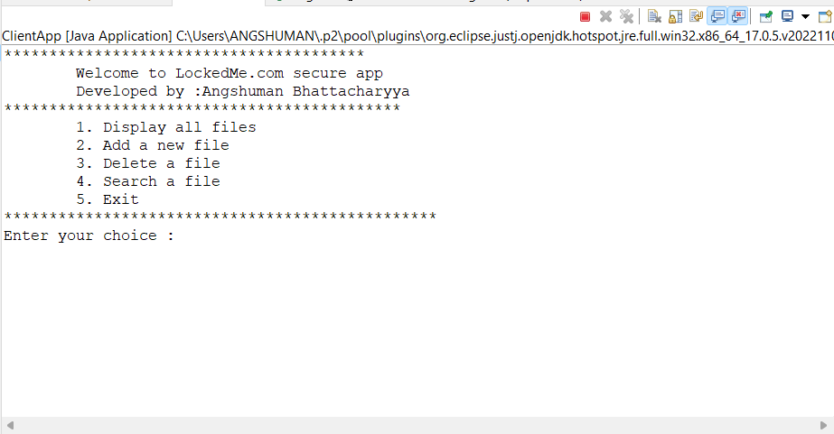

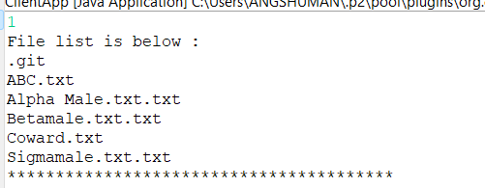

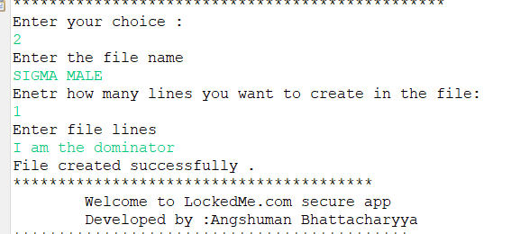

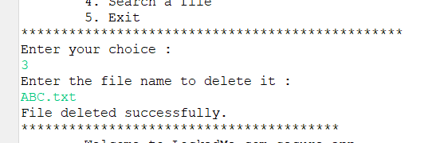

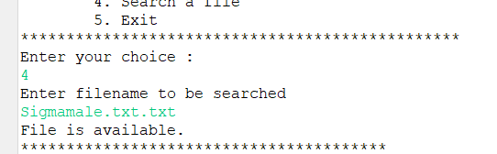

Github Link : https://github.com/angshuma123/Phase-1-Project.git